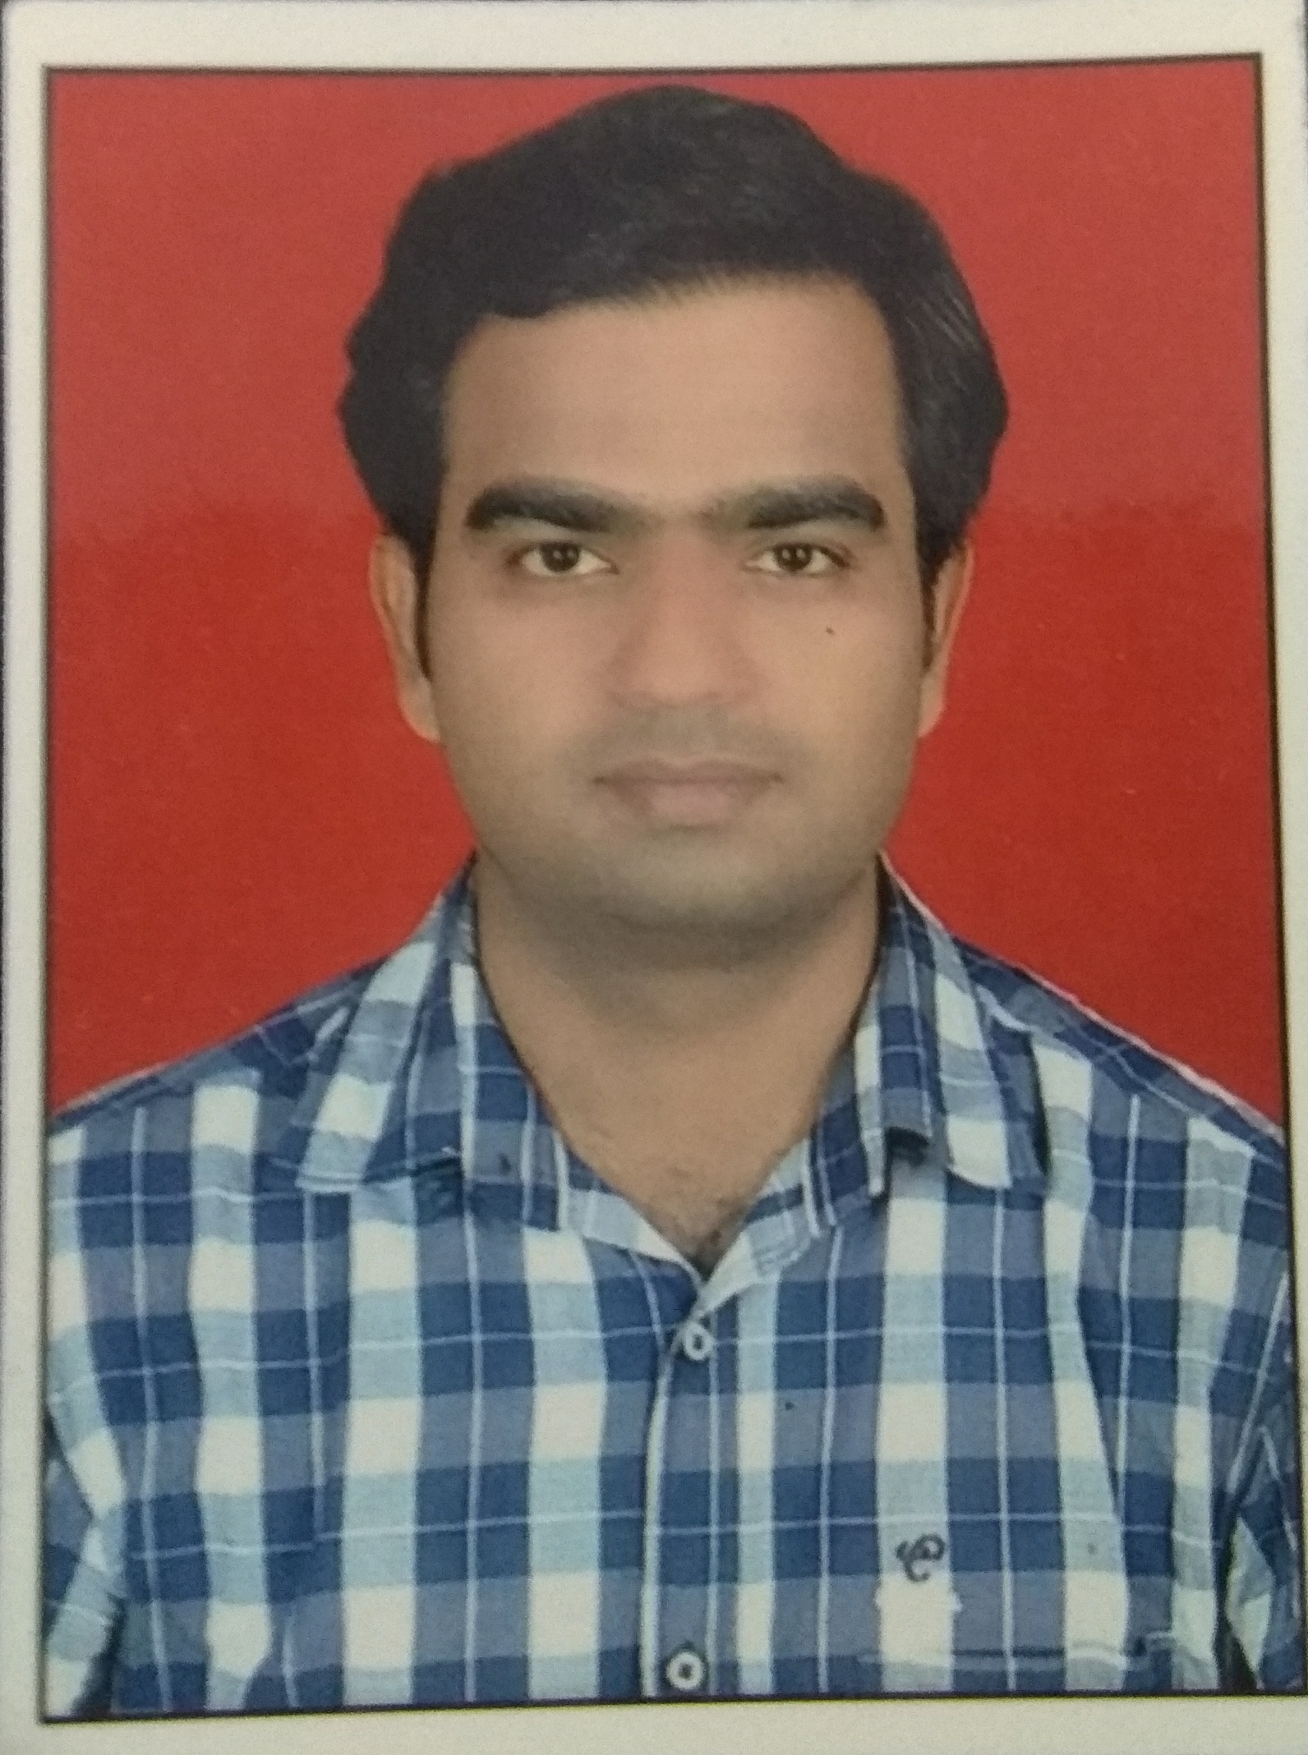

JECRC
JAIPUR

INDIVIDUAL FACULTY DATA SHEET
Name of the faculty member | : | Vikas Sharma
Present Designation | : | Asst. Professor
Email Id:
Contact Details:

I. Particulars of Educational Qualification: (only completed)

Category | Name of the Degree | Specialization | Year of Passing | Name of the College | Name of the University
UG | B.E. | ECE | 2009 | Govt. Engineering College, Ajmer | University of Rajasthan
PG | M.Tech | Digital Comm. | 2013 | Jagannath University
Ph.D.

II. Academic Experience : 8.5 Years

III. Industrial Experience : 6 Months

IV. Title of Ph.D. Thesis :

V. Awards/Achievements :

VI. Research/Specialization : Photonics Crystal Fibers, Digital Image Processing

VII. Course Taught : Mechatronics & Robotics, Digital Image processing, Optical
Communication, IC Technology, Electronic Devises & Circuits

VIII. Refereed International Journal Publication :

IX. International Conference Proceeding :

X. Books Written :

XI. M.Tech Thesis Guide :

XII. PHD Thesis Guide :

XIII. Professional Body Membership :

